
FOLYBIM ENGINEERING COMPANY NIG.

LTD
Electrical Mechanical Civil Engineering service & Consult Suite 25, Oja Oba Shopping Complex, Abule - Egba, Lagos
Our Ref: Your Ref:

Welcome to Folybim Engineering Nigeria Limited
At Folybim, we are more than just engineers—we are your partners in building a brighter and sustainable future. We specialize in designing, constructing, and installing cutting-edge power systems for industrial, commercial, and residential needs. Whether you need a reliable solution for powering your business or are exploring renewable energy options, our team is here to deliver innovative and efficient results.

What We Do
- Power Construction and Installation

  - Expertise in building and maintaining power systems from generation to distribution.  Tailored solutions designed for efficiency, reliability, and safety.

- Industrial Conduit Wiring

  - Top-notch wiring systems designed for even the most complex industrial setups.
  - Built to last, ensuring seamless performance and strict adherence to global safety standards.

- Solar Power and Inverter Solutions

  - Clean, green solar energy systems designed for homes, businesses, and industries.
  - Advanced inverter technology to help you get the most out of your energy.
  - Ongoing support to keep your system running smoothly.
FOLYBIM ENGINEERING COMPANY NIG.

LTD
Electrical Mechanical Civil Engineering service & Consult Suite 25, Oja Oba Shopping Complex, Abule - Egba, Lagos
Our Ref: Your Ref:

- Biomass Energy Systems
  - Renewable power solutions using innovative biomass technology.
  - Perfect for industrial and commercial applications, focusing on both efficiency and sustainability.

- Electrical Power Consultancy

  - Expert advice on designing, optimizing, and maintaining power systems.
  - Practical guidance on reducing energy costs, increasing efficiency, and meeting regulatory standards.
  - Expertise on ATS installations and repairs.
  - Energy audits and predictive/preventive maintenance on ATS equipments.
  - Installations of power transformers with quarterly preventive maintenance.
- Training and Capacity Building

  - Hands-on training programs for professionals in electrical and renewable energy technologies.
  -  
  - Workshops tailored to meet your team’s specific needs.

Our Vision
➢ We envision a world where industries thrive on sustainable energy, communities flourish, and the environment is protected. Our goal is to lead this transformation with cutting-edge solutions.

Our Mission
➢ To deliver electrical engineering services that are not only innovative and reliable but also cost-effective and environmentally friendly, while ensuring the highest standards of safety and customer satisfaction.
FOLYBIM ENGINEERING COMPANY NIG.

LTD
Electrical Mechanical Civil Engineering service & Consult Suite 25, Oja Oba Shopping Complex, Abule - Egba, Lagos
Our Ref: Your Ref:

Our Values
Innovation: We push the boundaries with the latest technologies.
Quality: Excellence is at the heart of everything we do.
Sustainability: We champion eco-friendly practices in every project.
Customer Focus: Your needs drive our solutions.
Integrity: We operate with honesty, accountability, and professionalism.

LTD
Electrical Mechanical Civil Engineering service & Consult
Suite 25, Oja Oba Shopping Complex, Abule - Egba, Lagos
Our Ref: ____________________ Your Ref:

COMPANY STANDARDS OVERVIEW
Engineering Service Execution Standards
Folybim Engineering maintains disciplined engineering procedures across electrical, mechanical, and civil service areas. Every project follows a structured lifecycle:
➢ Project Design Standards
- Engineering designs are developed using analytical calculations, load assessments, and system modeling.
- Designs prioritize efficiency, durability, maintainability, and safety.
- Solutions are tailored to industrial, commercial, and residential operating conditions.

➢ Installation & Construction Standards
- Use of technically appropriate materials and components.
- Skilled personnel handle system integration and installation.
- Installation practices ensure long-term system reliability and structural integrity.

➢ Power System Construction & Installation Standards
Folybim Engineering specializes in complete power infrastructure from generation interfaces to distribution networks.
Standards include:
- Accurate load forecasting and system sizing
- Proper protection systems (earthing, surge protection, circuit protection)
- Safe distribution layouts to prevent overloads and system failure
- Performance testing before commissioning
These standards ensure operational stability for industrial and commercial facilities.

Electrical Mechanical Civil Engineering service & Consult

Suite 25, Oja Oba Shopping Complex, Abule - Egba, Lagos
Our Ref: ____________________ Your Ref:

➢ Industrial Conduit Wiring Standards
For complex industrial environments, the company maintains strict wiring practices:
- Correct cable selection and load rating
- Mechanical protection of wiring systems
- Neat routing and labeling for maintenance accessibility
- Heat, vibration, and moisture-resistant installations This reduces downtime and enhances system safety.

➢ Renewable Energy System Standards
Folybim Engineering integrates sustainability into its technical standards. ➢ Solar & Inverter Systems
- Optimal panel positioning for maximum energy harvest
- Proper inverter sizing and battery integration
- System efficiency monitoring and post-installation support
➢ Biomass Energy Systems
- Energy conversion efficiency optimization
- Systems designed for industrial/commercial sustainability needs
- Focus on reducing dependence on fossil-based energy sources

➢ Quality Assurance & Control Standards
Quality is managed throughout all project stages.
- Pre-installation planning verification
- Material and component quality checks
- Functional testing after installation
- Performance validation before handover
- Ongoing system support and maintenance guidance

Electrical Mechanical Civil Engineering service & Consult

Suite 25, Oja Oba Shopping Complex, Abule - Egba, Lagos
Our Ref: ____________________ Your Ref:

➢ Health, Safety & Risk Management Standards Safety is integrated into all operations.
- Hazard identification and risk assessment before project start
- Mandatory use of personal protective equipment
- Safe handling of electrical and mechanical systems
- Continuous site supervision and safety monitoring
- Incident prevention culture

➢ Environmental & Sustainability Standards
The company aligns engineering practices with environmental responsibility:
- Promotion of renewable energy adoption
- Energy-efficient system designs
- Waste minimization during installations
- Sustainable engineering methods that reduce environmental impact

➢ Project Management & Client Collaboration Standards
Folybim Engineering applies structured project coordination methods:
- Clear project scoping and requirement analysis
- Transparent communication throughout project phases
- Timely execution and milestone tracking
- Client-centered solution adjustments • Post-project technical support.

Electrical Mechanical Civil Engineering service & Consult

Suite 25, Oja Oba Shopping Complex, Abule - Egba, Lagos
Our Ref: ____________________ Your Ref:

➢ Technical Training & Capacity Building Standards To maintain competence and industry relevance:
- Hands-on technical training programs
- Knowledge transfer in electrical and renewable technologies • Workshops tailored to professional development needs.

➢ Corporate Ethics & Professional Conduct Standards
Folybim Engineering operates on strong ethical foundations:
- Transparency in technical and commercial dealings
- Accountability for project outcomes
- Respect for client confidentiality
- Professional conduct in all engagements

➢ Innovation & Continuous Improvement Standards
- Adoption of modern engineering technologies
- Continuous improvement of power system solutions
- Research-driven service enhancement
- Skills development to meet evolving energy demands.

LTD

Electrical Mechanical Civil Engineering service & Consult Suite 25, Oja Oba Shopping Complex, Abule - Egba, Lagos
Our Ref: Your Ref:

➢ Alignment with Corporate Vision & Mission
All company standards support the organization’s commitment to:
- Sustainable energy development
- Reliable and cost-effective engineering services
- Environmental protection
- High safety and customer satisfaction levels

➢ Conclusion
Folybim Engineering Company Nigeria Ltd maintains structured, safety-conscious, quality-driven standards that ensure dependable engineering outcomes. These standards position the company as a technically capable, environmentally responsible, and professionally reliable contractor suitable for public and private sector projects.

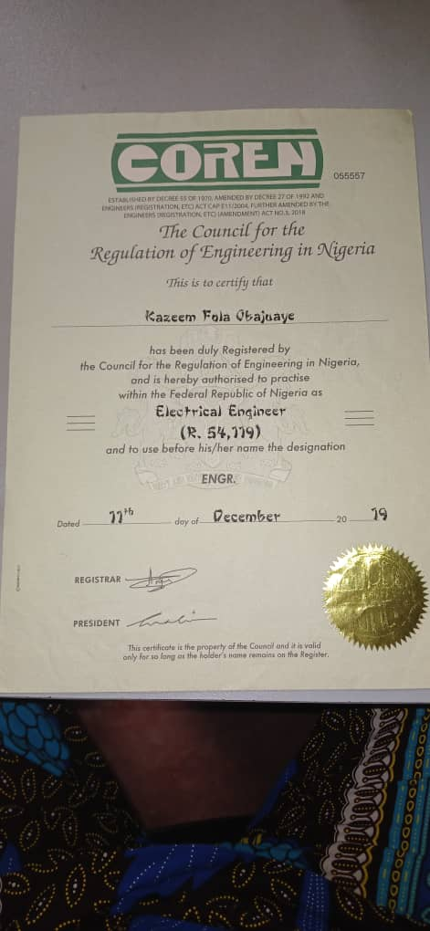
COREN CERTIFICATION. MEMORANDUM AND ARTICLES

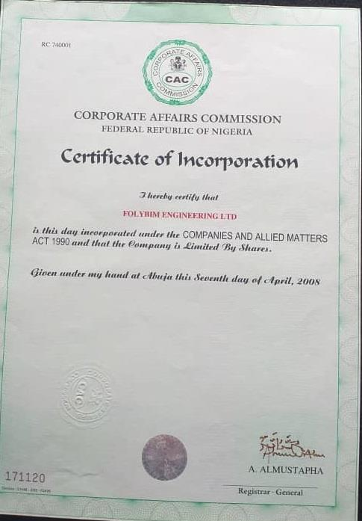
CERTIFICATE OF INCORPORATION.

Electrical Mechanical Civil Engineering service & Consult Suite 25, Oja Oba Shopping Complex, Abule - Egba, Lagos
Our Ref: Your Ref:

OUR PORTFOLIO OF CLIENT PROJECTS
PAST PROJECTS
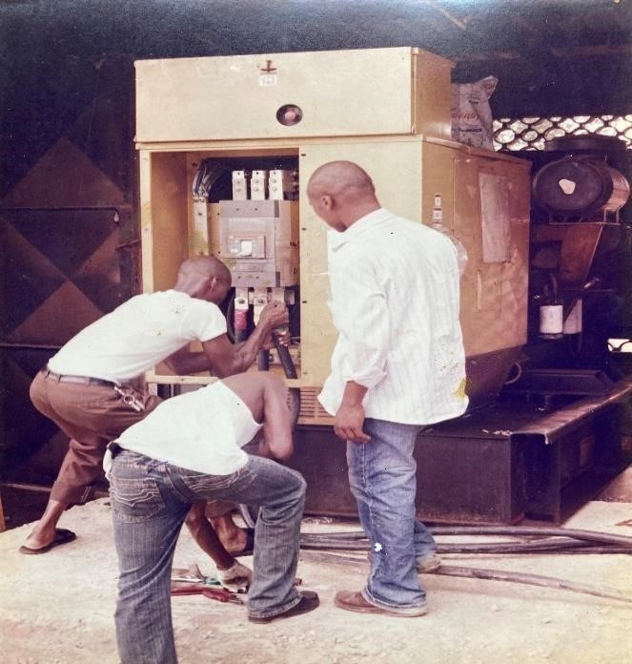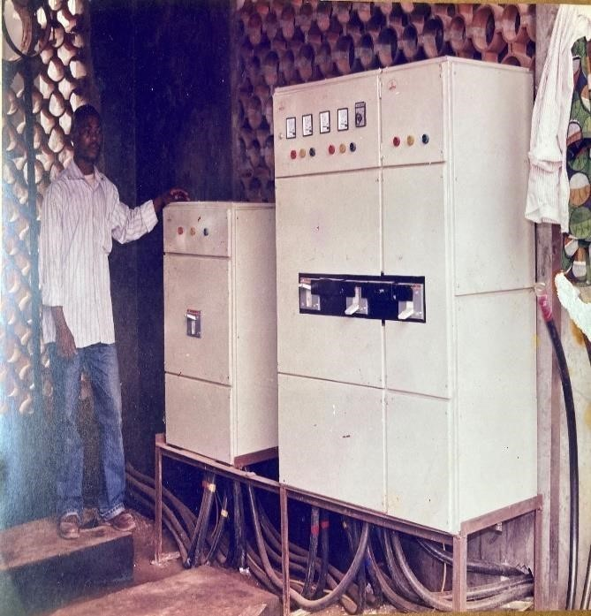
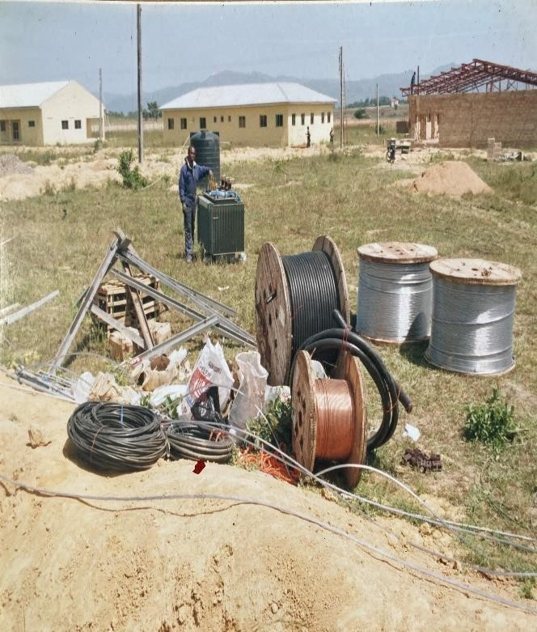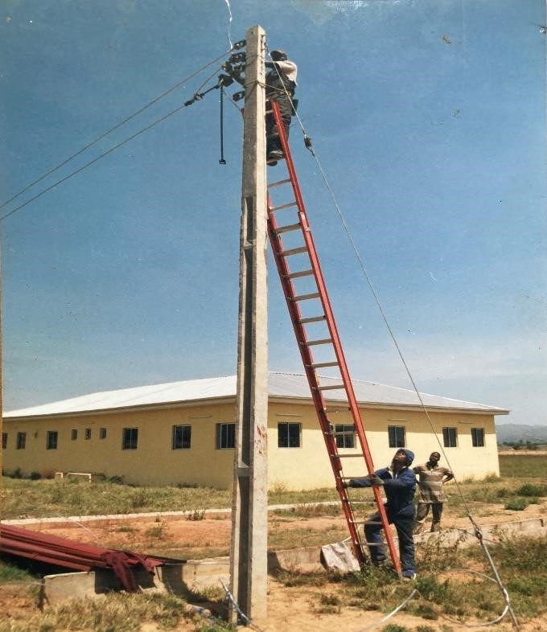


LTD

FOLYBIM ENGINEERING COMPANY NIG.

LTD
Electrical Mechanical Civil Engineering service & Consult Suite 25, Oja Oba Shopping Complex, Abule - Egba, Lagos
Our Ref: Your Ref:

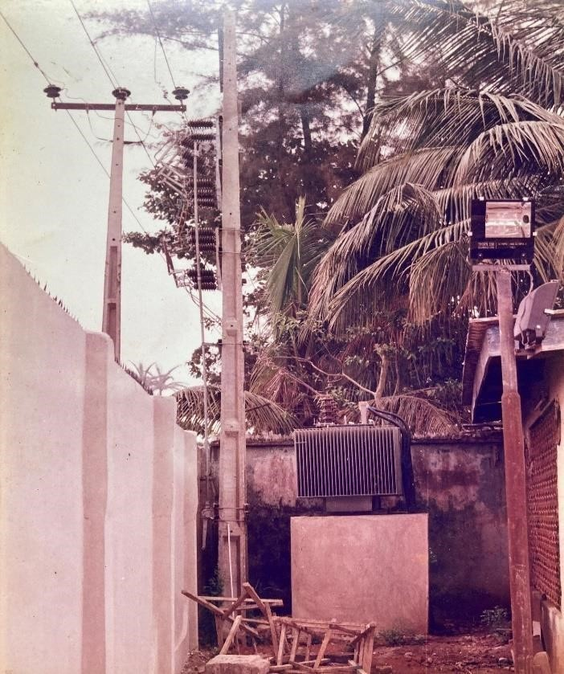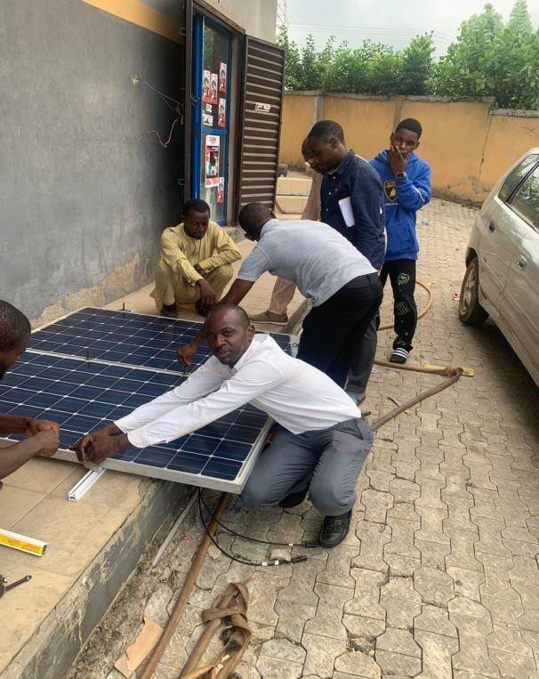

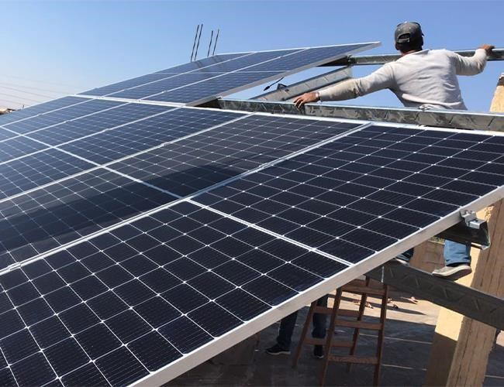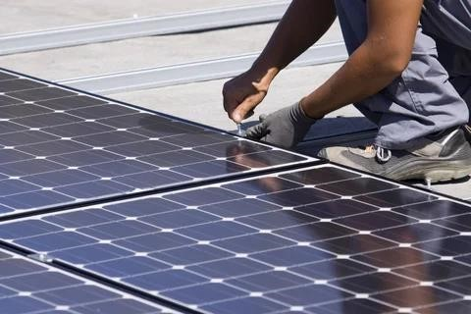

Electrical Mechanical Civil Engineering service & Consult Suite 25, Oja Oba Shopping Complex, Abule - Egba, Lagos
Our Ref: Your Ref:

CURRENT PROJECTS AT IHS
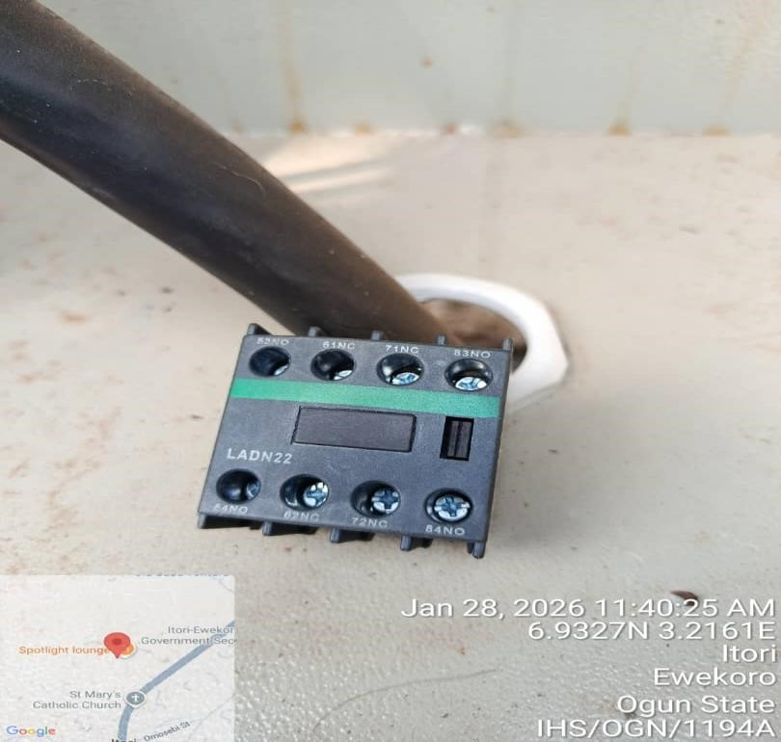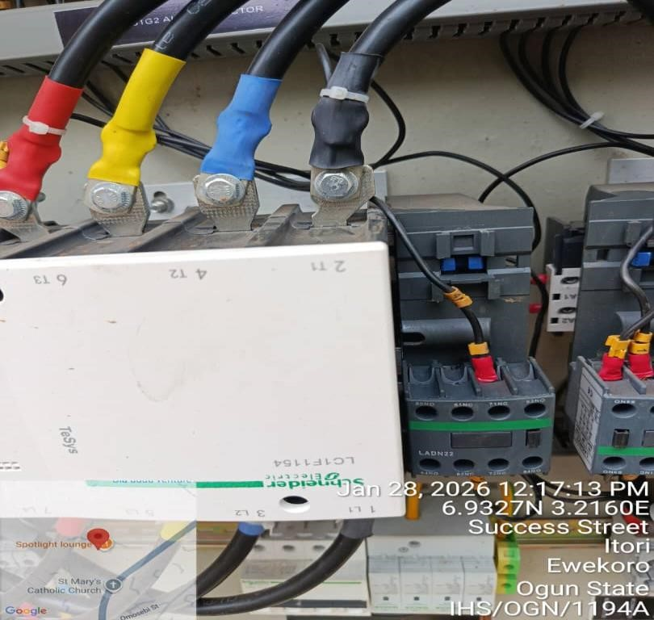

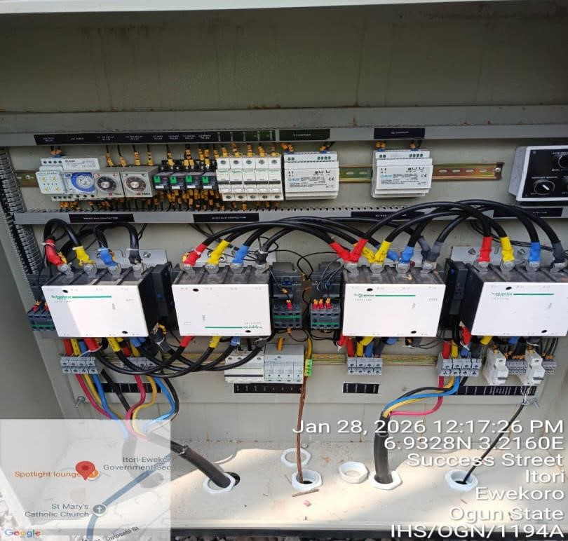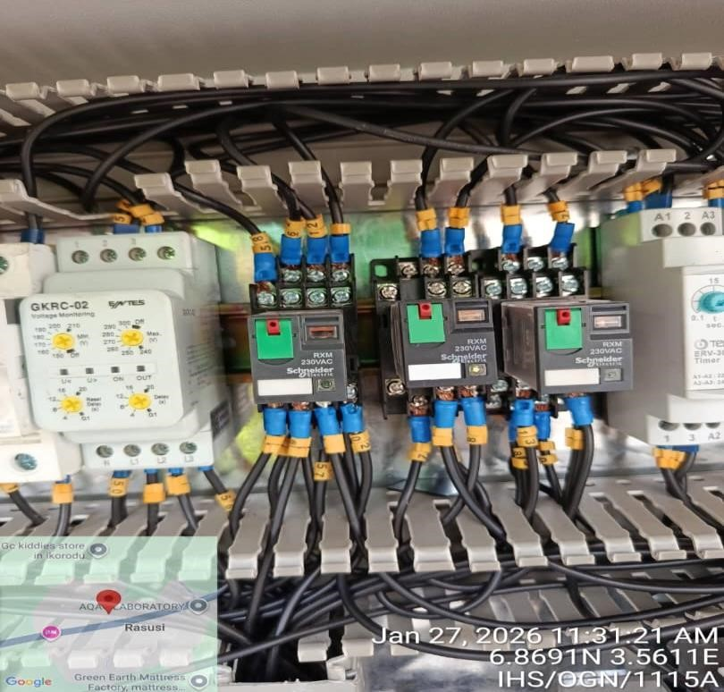

LTD

Electrical Mechanical Civil Engineering service & Consult Suite 25, Oja Oba Shopping Complex, Abule - Egba, Lagos
Our Ref: Your Ref:

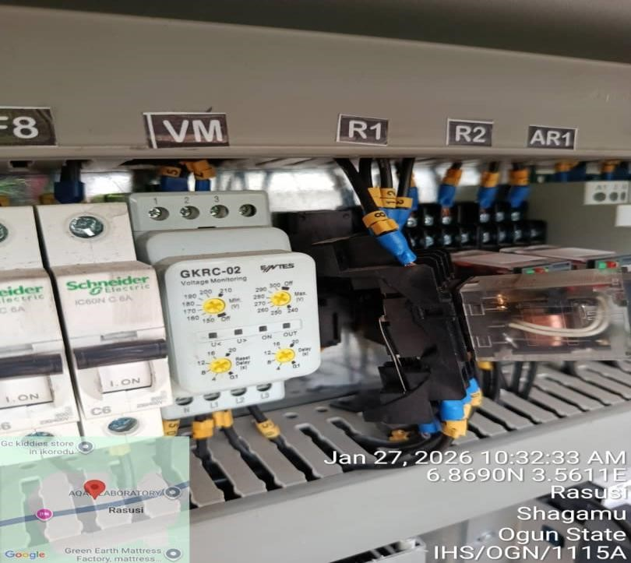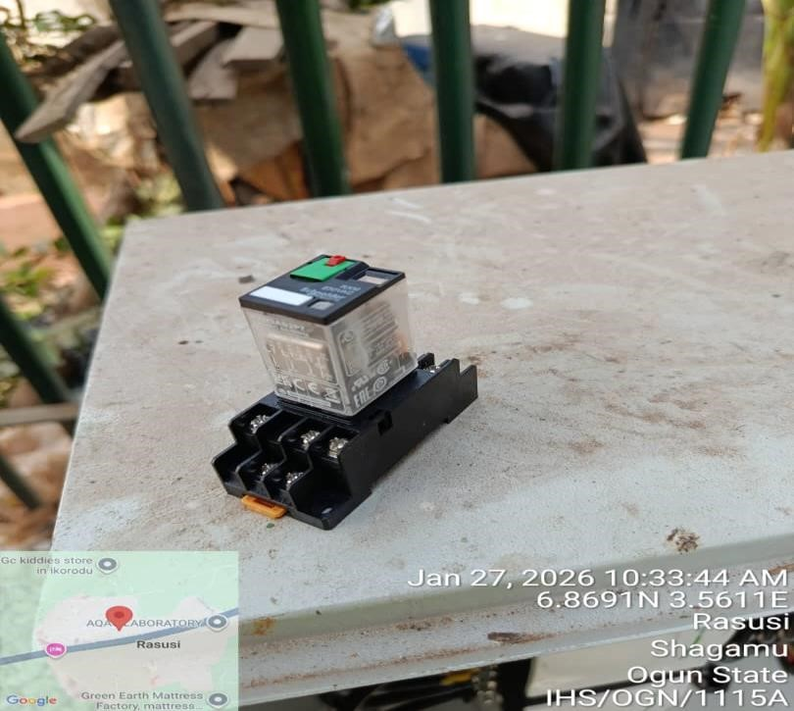

i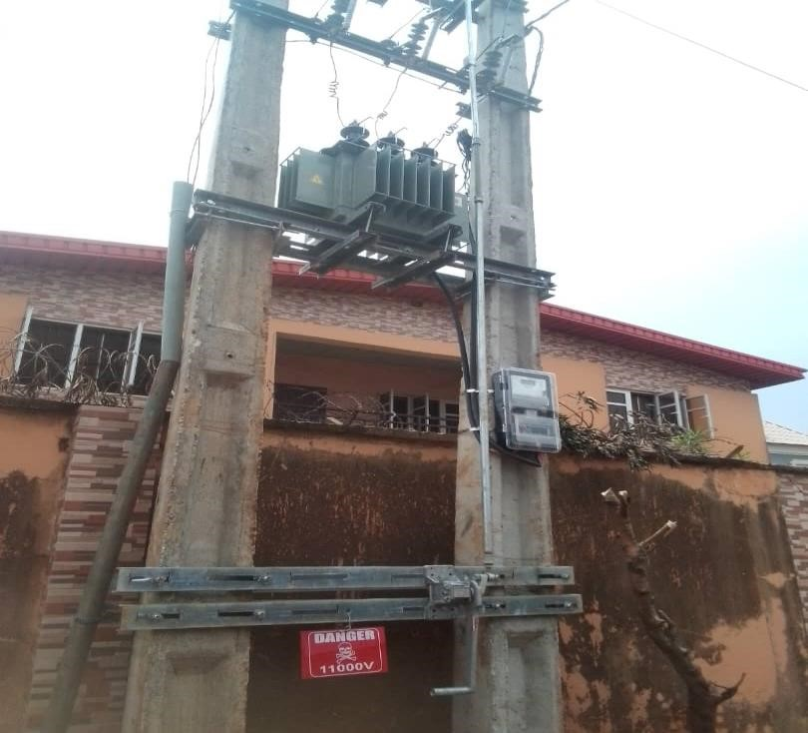

IHS LAG 1951, ONA ARA STREET, IDIMU LAGOS.

Electrical Mechanical Civil Engineering service & Consult Suite 25, Oja Oba Shopping Complex, Abule - Egba, Lagos
Our Ref: Your Ref:
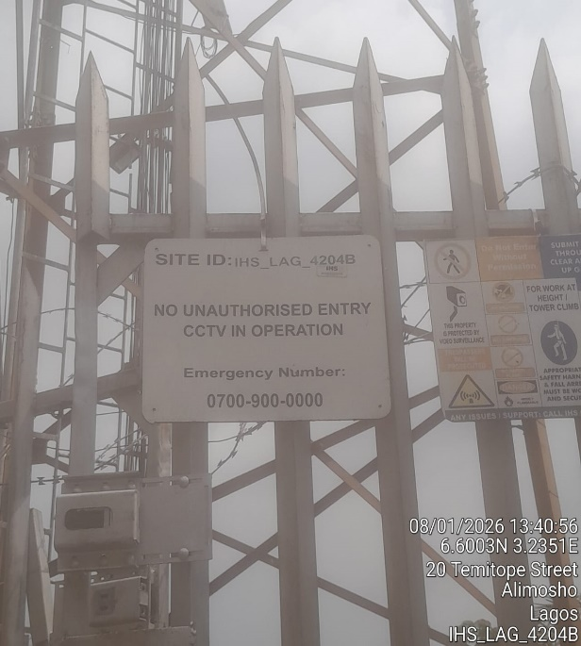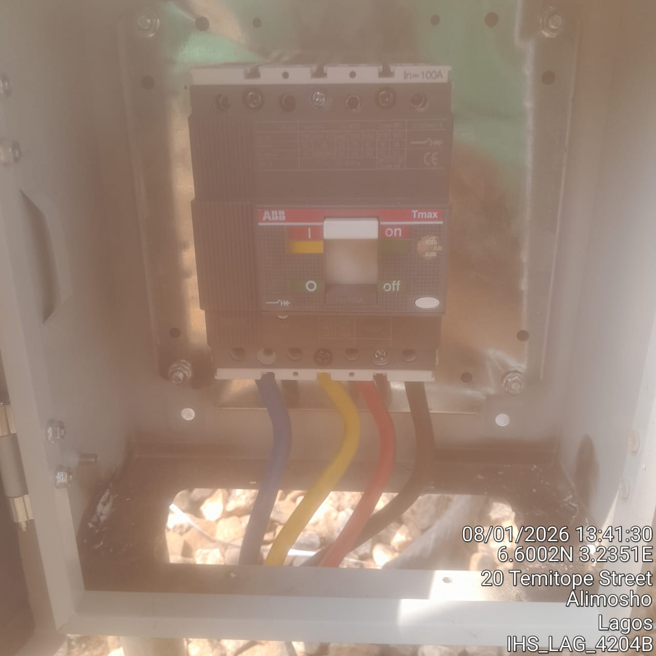

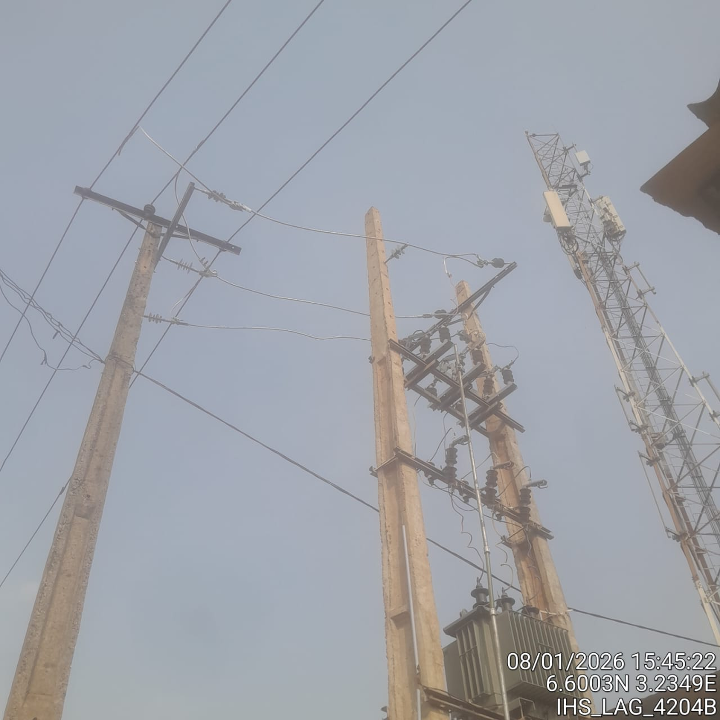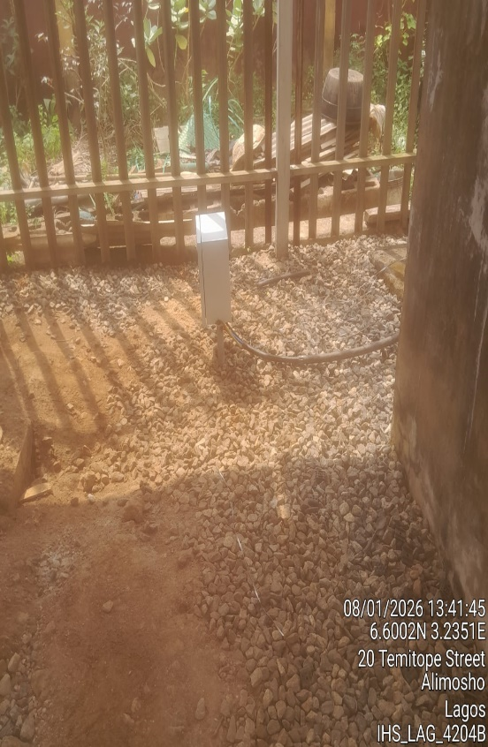

Why Work With Us?
- Experienced Experts: Our skilled engineers and technicians bring years of expertise to every project.
- Proven Results: We’ve successfully powered industries across sectors.
- Safety First: We prioritize quality and safety in every project.
- Tailored Solutions: Your unique needs are our top priority.
- Innovative Thinking: We stay ahead through research and development.

Let’s Connect
Ready to transform the way you power your world? Contact us today!

Address: Suite 25, Oja-Oba Shopping Complex, Abule-Egba, Lagos.
Phone: 08056661386, 08037274353
Email : Kazzlaye@gmail.com
Olakunleolufemi75226@gmail.com

At Folybim Engineering, we’re not just powering the present—we’re building the future.

